**Understanding In-app Ads and Detecting Hidden Attacks through the mobile App -Web Interface.**

Table of Contents

I. Project Details 6

II. Requirement Specification for Phase - 2 7

1.1 Admin Module Requirements: 6

1.2 User Module Requirement: 8

2. Non-Functional Requirements Developed Under Phase - 2 12

2.1 Security Requirements: 12

2.2 Privacy Requirements: 12

2.3 Scalability and performance Requirements: 12

2.4 Usability Requirement: 12

2.5 Compatibility Requirement: 12

3. Interfaces (user, hardware, software, and/or communication) Developed Under Phase - 1 12

3.1 Hardware Interface Requirements: 13

3.2 Software Interfaces Requirements: 13

3.2 User Interface: 13

III. UML Design 16

1. Class diagram 16

2. Sequence diagram 17

3. Use case diagram 18

IV. Test Cases 20

V. User Manual for Phase - 1 31

VI. Program Compilation and Run Instructions 55

1. Program Instructions 55

2. Testing Instructions 56

VII. Feedback 56

VIII. Accomplishments 57

IX. Member contribution table 57

# Project Details

**Project Title: Project Title:**  **Understanding In-app Ads and Detecting Hidden Attacks through the mobile App -Web Interface.**

**Group Name:** Team Resolve

**Group Members:**

1. Navyasri Arekatla
2. Lokesh Bachu
3. Sushma Bobbishetty
4. Naveen Bolgom
5. Sathvik Cheekati
6. Vamshi Teja Goud Puli
7. Shiva Teja Reddy Yammanuru

# Requirement Specification for Phase - 2

## Functional Requirements Developed under Phase – 2 with respect to each module

As part of phase-2 we have added few extra functionalities and changed few existing features,

### Admin Module Requirements:

#### Registration/ Sign-up:

* The project needs to be deployed, and the server needs to be started. Because of this, we are able to access the project dashboard as well as all of the files that are linked with the project.
* In order to register for the browser, administrators are required to provide the appropriate information throughout the registration process.
* The Apache software is being used in place of a browser on our system. The software known as Apache is a web server that listens for HTTP requests sent in by users and then provides those users with the information they want in the form of web pages.
* Administrators can begin the registration process by clicking the "Admin Login" button located on the home page. This will prompt them to provide their organization's email address and password.
* When users click the button, the page that prompts them to register is displayed.
* After the administrator has been signed up for the course. It is a good time to access the browser.

#### Login Validation:

* In order to log in, the administrator needs to click the icon labeled "Admin Login." The person's credibility has been investigated thoroughly.
* If any of the information is incorrect, the error message "Invalid Username or Password" will be displayed.
* If you go into your settings and select "Forget Password," you will have the ability to alter your password whenever you like. Each of the password-related fields—Email ID, Contact Number, New Password, and Confirm Password—is currently blank. When the correct Email ID and Contact Number are given, the passwords can then be updated successfully. If you select "Cancel," the update will no longer be downloaded.

#### Dashboard Display:

Admin Dashboard has following sections:

##### ADMIN MENU:

The administrator has access to a vast array of settings through the use of a menu called "admin," which features a variety of options.

The Admin access are the below:

**View all users and authorize**: We are able to view the requests made by all users and grant or deny them as necessary. The admin is the only one who can create authorized users, and those users are the only ones who can access the user dashboard.

**View all android users**: This module presents information about all Android users.

**View advertisement request users:** advertisements that the user has requested to see are displayed in this section. We are able to accommodate the request through the use of this interface.

**View friend request and responses** This section of the module displays all of the friend requests and the responses to those requests.

**View All user’s advertisement with rank and rating** This section compiles and displays all of the advertising that has been registered by users, along with their position and score.

**View all Malicious user details:** This module gives users the ability to access the information associated with the malicious user. This provides the administrator with the ability to identify harmful individuals and prevent those people access to any additional advertising.

**View all advertisement recommended users details:** This module will display advertisements that have been recommended by other users.

**View malicious publishers:** This component provides the administrator with a list of all malicious publishers that have been reported by users. This module provides assistance to administrators in determining how to steer clear of fake publishers for advertising purposes.

**View all android hidden attackers:** This module grants the admin the ability to view all hidden Android attackers, and it is useful for that purpose.

**View all expired advertisements:** See all advertisements that have since expired This module gives the administrator the ability to view all advertisements that have since expired.

**View all blocked users:** This module makes it possible to view every one of the users who have been blocked by the administrator.

**View all blocked user’s evidence:** This module provides the admin with a comprehensive view of all the evidence connected to blocked users.

**View user type count in chart** See type count for user in chart The administrator can use this module to view all of the type counts that are displayed in the chart for the user.

**View all advertisement ranks in chart:** This provides the administrator with the ability to view all of the ranks of the advertisements in the order in which they were received. The administrator will be able to check this and see where each of their advertisements currently stands in the rankings.

**Logout:** By selecting this option, the Admin can log out of the dashboard completely.

### 1.2 USER REGISTER MODULE Requirement:

#### Registration/ Sign-up:

* In order for users to access our web browser, they are required to create an account with us and supply us with the necessary information. This data consists of the email address of their company as well as a password for accessing the associated account. Our web browser wouldn't function without the Apache software running in the background.
* Users can begin the registration process by selecting "User register Login" from the homepage menu, then providing their email address and choosing a password. If they click on the button, the registration page will open and it will prompt them to provide the information it requires.
* After the user has concluded the registration procedure, they will be able to access their accounts through a web browser and sign in. They will have access to all of the features and functionalities of our web browser as a result of this.

#### Login Validation:

* Users can access the dashboard and check in. To use this service, users must first sign up on the site and provide the essential information. After successfully registering, users can log in to the user module.
* To access the user module, users must select "USER" from the dashboard menu and then input their login details. A user must first register as a user and have that registration approved by the administrator before they can access the user module.

#### Dashboard Display:

The User dashboard display is seen only when the admin authorizes the User request. The user will be keeping the request to the admin when he wants to keep an advertisement in the dashboard in order to promote his advertisements.

##### User menu:

The user dashboard provides a comprehensive overview of all of the functionalities that are at their disposal for use by the user.

##### Profile:

In the profile, the person’s information is available. The information related to the user is given in this module.

###### Search friends:

With this module, we can look for friends and make new ones. We can find our friends and invite them.

###### Manage bank accounts:

A part of the system tells the user about their account. In this module, users can enter their bank account information and register their own bank account. Users can also look at their account statement through this module.

##### send request to admin to launch advertisement:

* Here, we will write down the date and time we want the ad to run. The admin will then look over the request and give the green light.
* After the request is approved, we will have to pay to have the ad put up.

##### add advertisement details:

* Once the advertisement request is accepted by the admin we can now add the details of our advertisement in the given browser.
* It asks for some details such as category, name, file, content and the time duration of the advertisement in the browser.

##### view all my advertisement details:

* By the use of this module, you will be able to view the advertisements that have been posted together with the duration of time that each one will remain active.
* In addition to that, you have the option to remove any advertisement that you no longer wish to view.

##### all my friends advertisement details and recommend to other friends:

* In this module, we can view our friends advertisements and recommend them to other friends.

##### friends recommended advertisements:

* With this module, you can see what ads have been posted and how long each one will be up. You can also get rid of the ads you don't want to see anymore.

##### Logout:

Users can logout just by clicking this button.

## Non-Functional Requirements Developed Under Phase - 1

### Security Requirements:

Using Java functions and JavaScript in the HTML file of the application to implement user authentication makes sure that the application is safe. This means that users must enter their login information to get into the application, and the application's authentication system checks that the information is correct.

Also, the application can only be used on websites that have given it permission to do so. This helps stop unauthorized access and makes sure the app is only used in the way it was meant to be. If the application is tried to be run on a website that isn't supposed to have it, it won't work.

### Privacy Requirements:

Other than the user's email address, which they will submit in order to complete the registration procedure, the application to which you are referring will not reveal any personally identifiable information about its users. JavaScript will be used during the login process to verify the user's identity and confirm that they are permitted to use the program. This will ensure that only authorized users may access the application. Before providing the user access to the program's functionalities, the application will, in essence, do a verification check using the email address and password that the user has provided for the application.

### Scalability and performance Requirements:

This application provides users with a web-based platform that enables them to not only create and manage their own adverts but also connect with one another. In order for us to use this platform, we need to have a cloud server and a domain to host the application on. This project is on par with larger-scale projects in terms of its level of complexity and scope.

### Usability Requirement:

It is essential to place a strong emphasis on the application's usability when developing it for end users. Using different kinds of technology, such as Ajax, jQuery, and Java, is one of the most efficient ways to make an application more user-friendly.

The user is able to engage with the application without the need for the complete page to reload since Ajax enables asynchronous communication between the front-end and back-end of the application. This can help to improve the user experience by lowering the amount of time that users have to wait for the program and increasing the responsiveness of the software.

The JavaScript library jQuery streamlines the process of interacting with the Document Object Model (DOM) of a web page. DOM stands for "Document Object Model." When developers write code with jQuery, the resulting code is shorter, clearer, and simpler to read and maintain, all of which contributes to an improved experience for the end user.

Java is a computer language that is extensively used because of its reputation for scalability and performance. Developers are able to design sturdy and reliable systems that are capable of handling massive volumes of data and traffic when they use Java on the backend of an application to create the application.

The combination of these technologies has the potential to assist software developers in the production of programs that are more user-friendly, intuitive, and responsive to the end user's needs.

### Compatibility Requirement:

Running our application on following browsers is more compatible:

1. Chrome Browser Version 98.0.0.0 or above
2. Microsoft Edge Version 90 or above
3. Safari Browser Version 13.1.2 or above

## Non-Functional Requirements Developed Under Phase - 2

### Security Requirements:

We will be using JavaScript functions for User Authentication and securing user data. Even during DOS attacks, the software must be available and behave consistently. The integrity of the customer account information must be ensured by the software. Any browser that the server cannot authenticate should not be served a restricted web page.

### Privacy Requirements:

The application does not show any personal information of users apart from the email id that will be used while registering. We will be using Java Script for Authenticating the login credentials.

### Scalability and performance Requirements:

All the employees in the organization will be working on the bug tracking system, as a part of their daily job. Hence the web page needs to be highly responsive and should perform at a greater speed, we will be using XAMPP server that is highly scalable.

### Usability Requirement:

Usability plays a key role as this application works as a bridge between the user interface and should be well-designed. We will be using jQuery and Ajax programming to make web pages user friendly. For the users to learn quickly and understandably, we will take them on a tour of the options and actions available to them.

### Compatibility Requirement:

Our website should be compatible in working in the following browsers.

1. Chrome Browser Version 98.0.0.0 or above
2. Microsoft Edge Version 90 or above
3. Safari Browser Version 13.1.2 or above

## Interfaces (user, hardware, software, and/or communication) Developed Under Phase - 2

### Hardware Interface Requirements:

This application can be runed on a web browser which is installed on **Laptop / PC**.

### Software Interfaces Requirements:

1. **HTML**: For website Designing.
2. **JQUERY:** For styling the website Design.
3. **AJAX:** Used for Dynamically loading the webpages.
4. **JavaScript**: This Technology is used to apply validations for web pages and redirections etc.,
5. **SQL:** We will be using SQL for accessing the database.
6. **Visual Studio:** We will be using Visual Studio as Integrated Development Environment for the Project.
7. **Apache Tomcat:** It is used as a server for deploying the application.

### User Interface:

Here is the Landing page of the application.

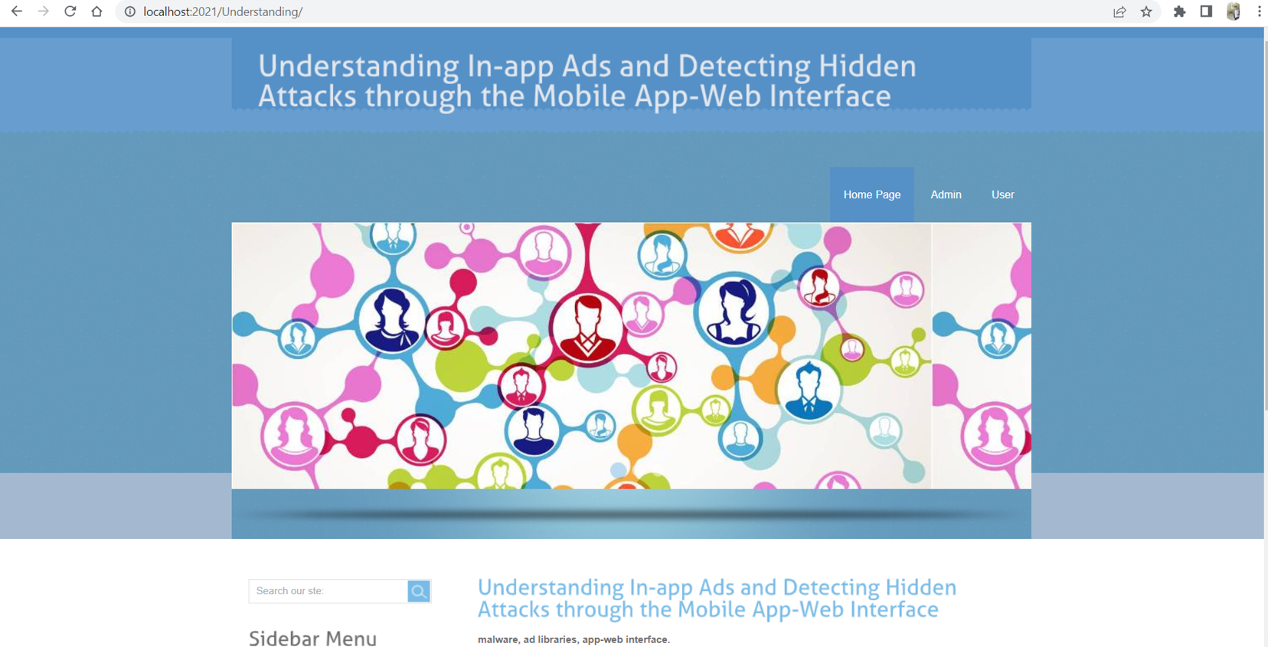

Step 2: This page displays the menu options like Home, Admin, User

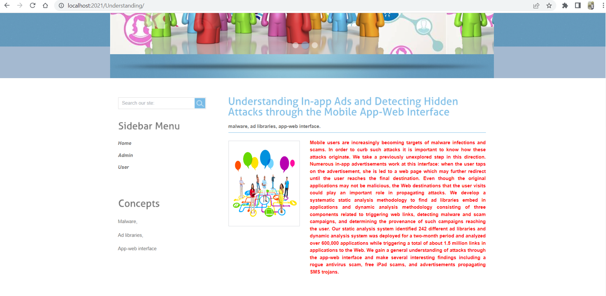

Step 3: By selecting the user from the menu we can land into this page. That is User Login page. As the new user we need to select Register here.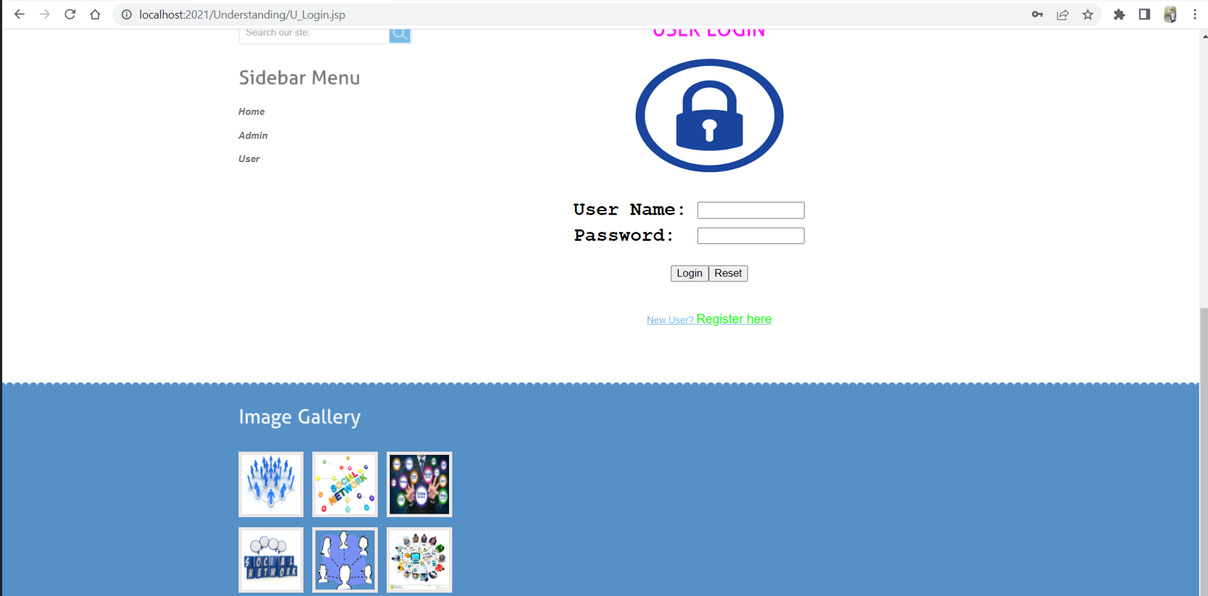

Step 4: By selecting the register here, we need to provide the details of the user.

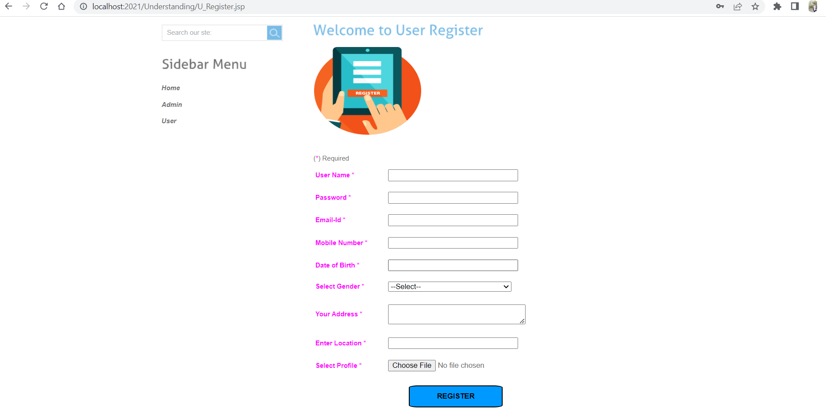

Step 5: In the below screenshot user details are displayed to register.

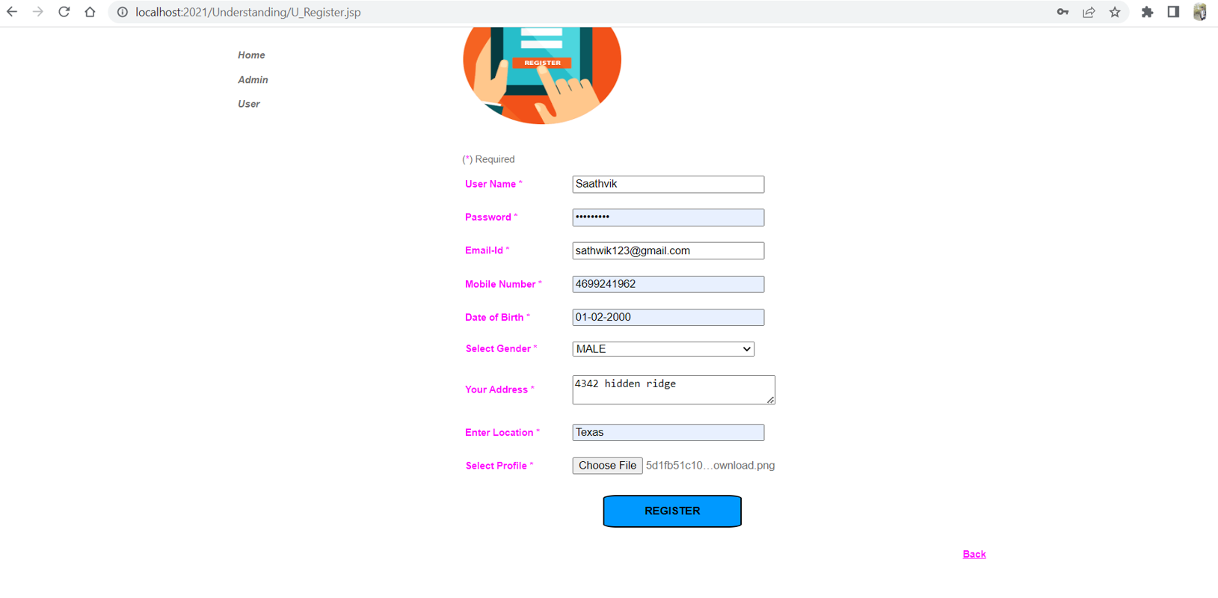

Step 6: This page going to display after the successful completion of the registration.

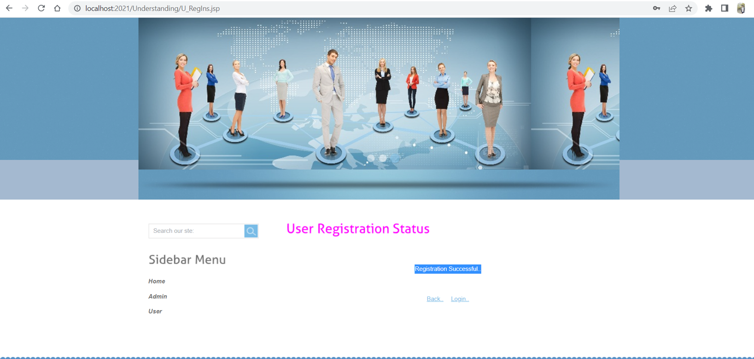

Step 7: Here is the User Login Page

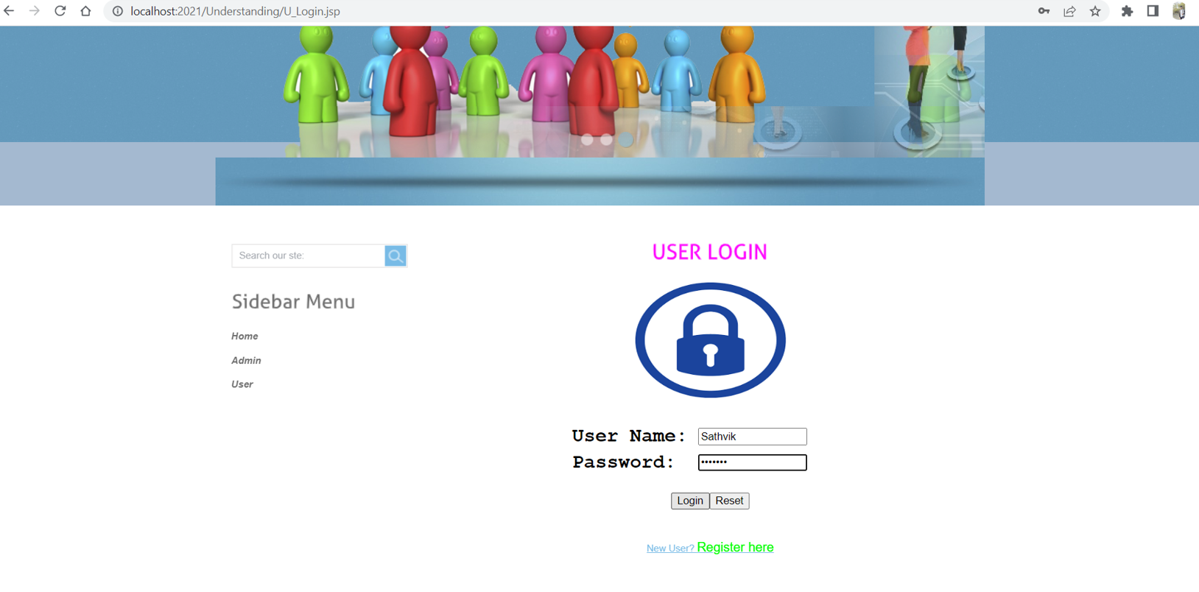

Step 8: Here is the Admin page of the application.

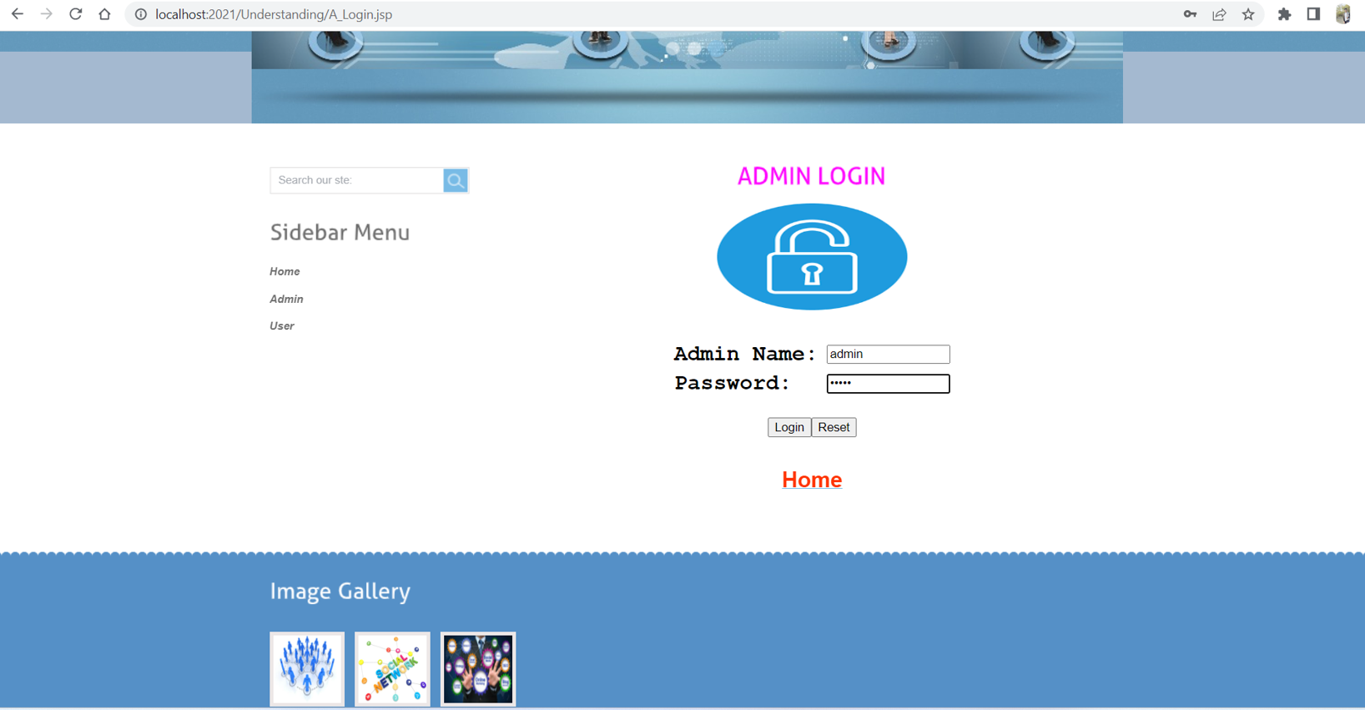

Step 9: In the below screenshots it displays the home page of the admin page.

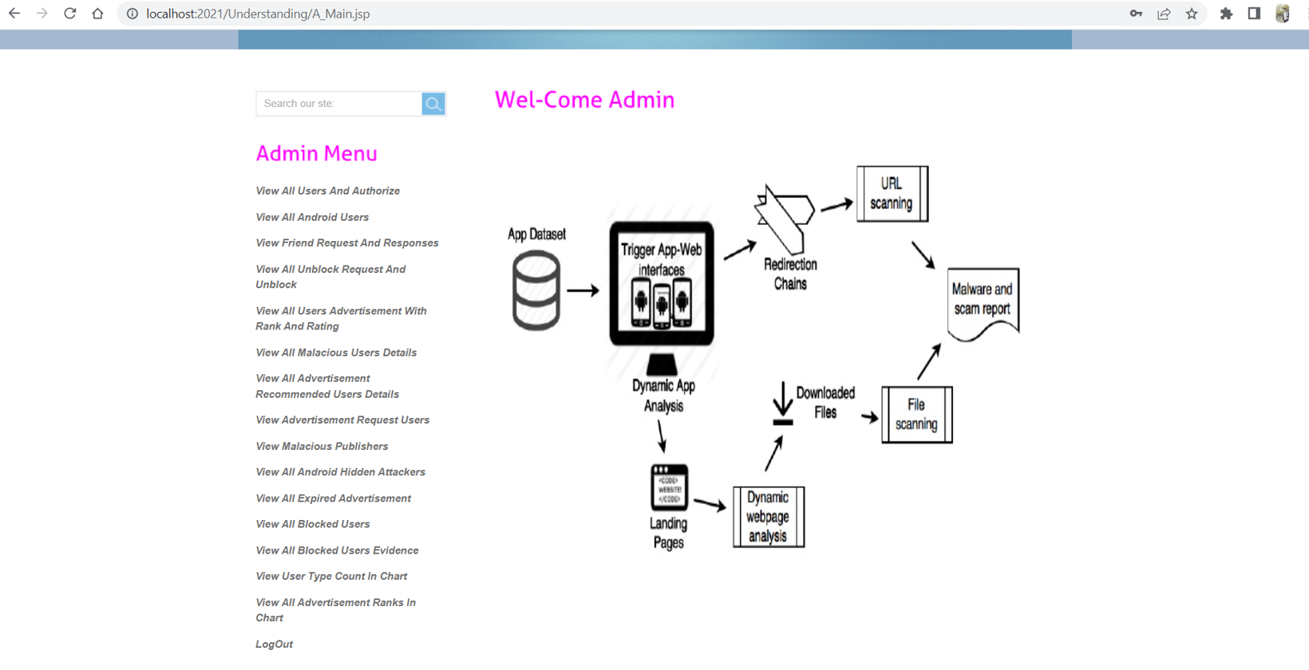

Step 8: By selecting the View All Users And Authorize it will display the below page. Here, the admin needs to authorize the user for login to this application.

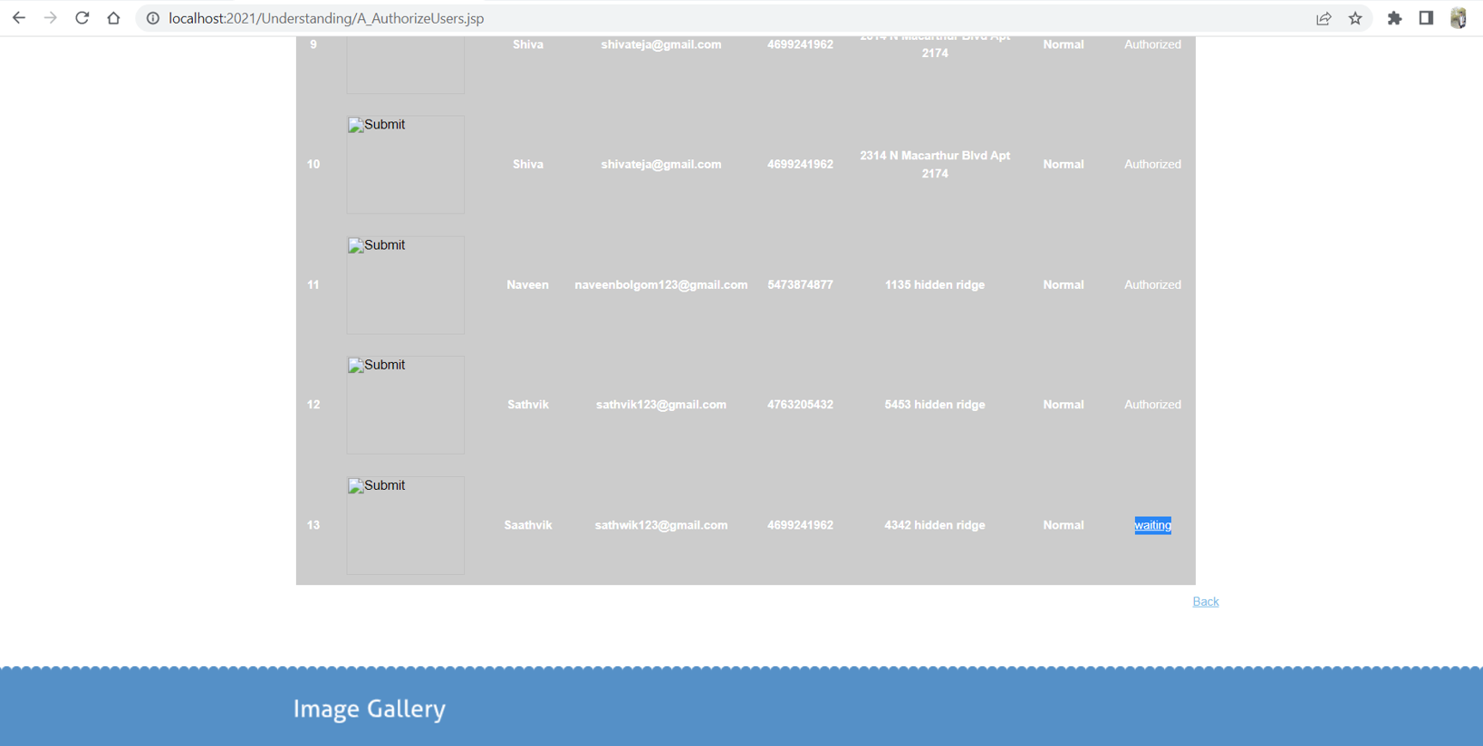

Step 9: After the successful authorization, user can login into their account.

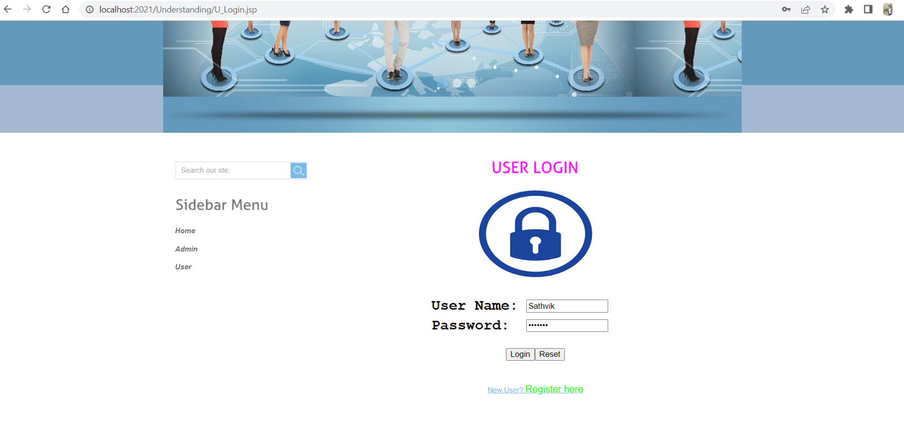

Step 10: Here is the home page of the User.

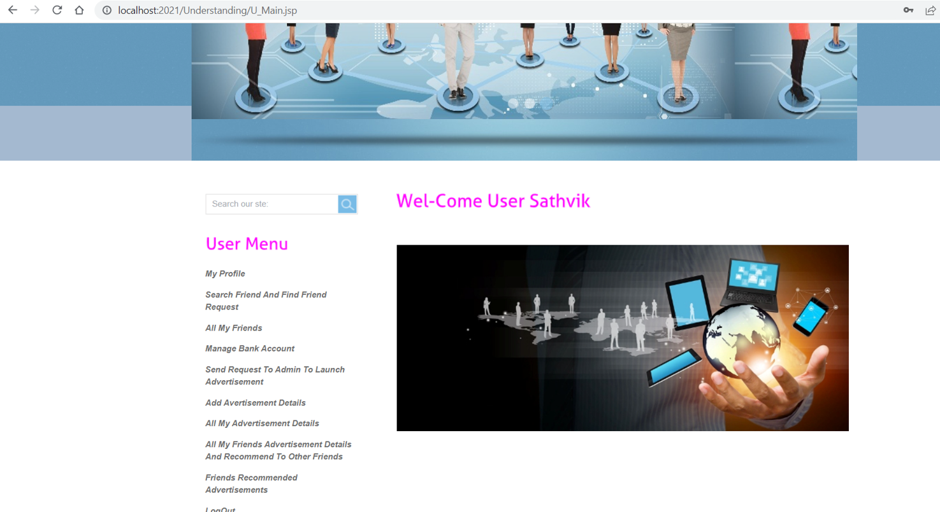

# UML Design

## Class diagram

## 

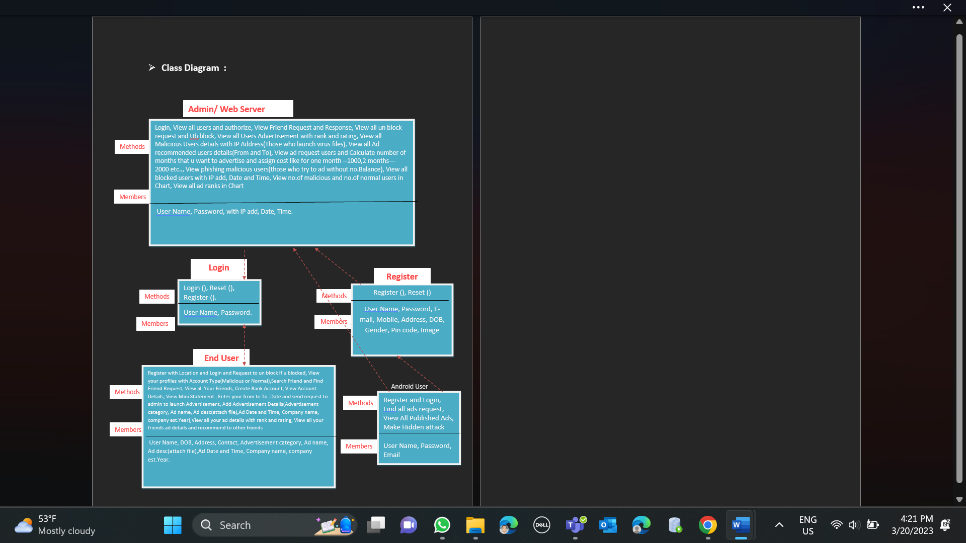

Figure : Class Diagram

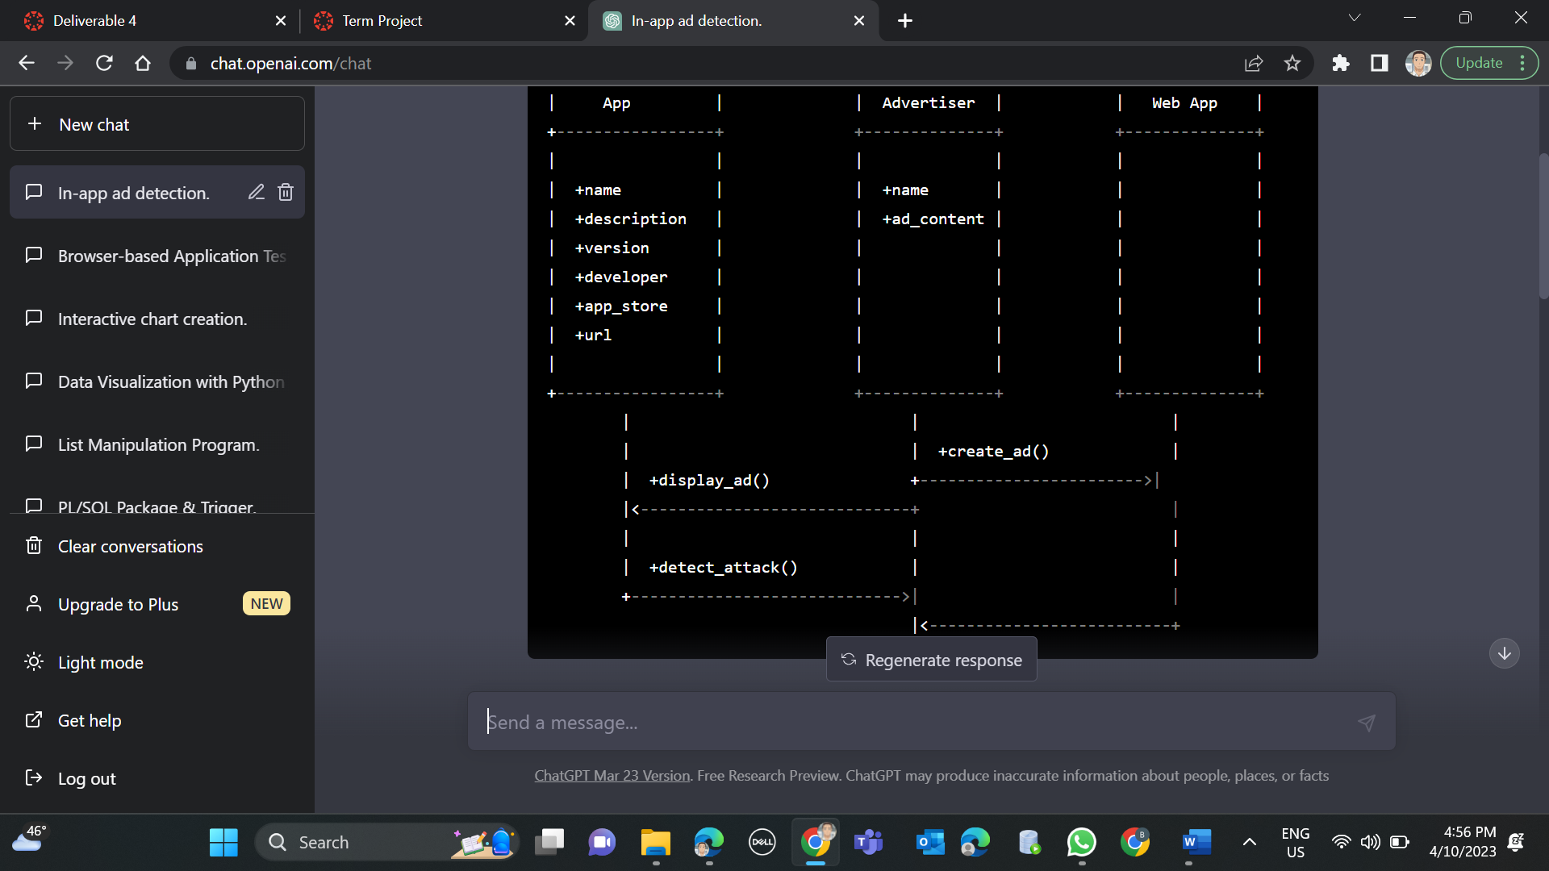

Another Class Diagram defining the application in simple functional format.

## Sequence diagram

Sequence diagram for “Understanding In-app Ads and Detecting Hidden Attacks through the mobile App -Web Interface.” with respect to the Phase – 1 Requirements.

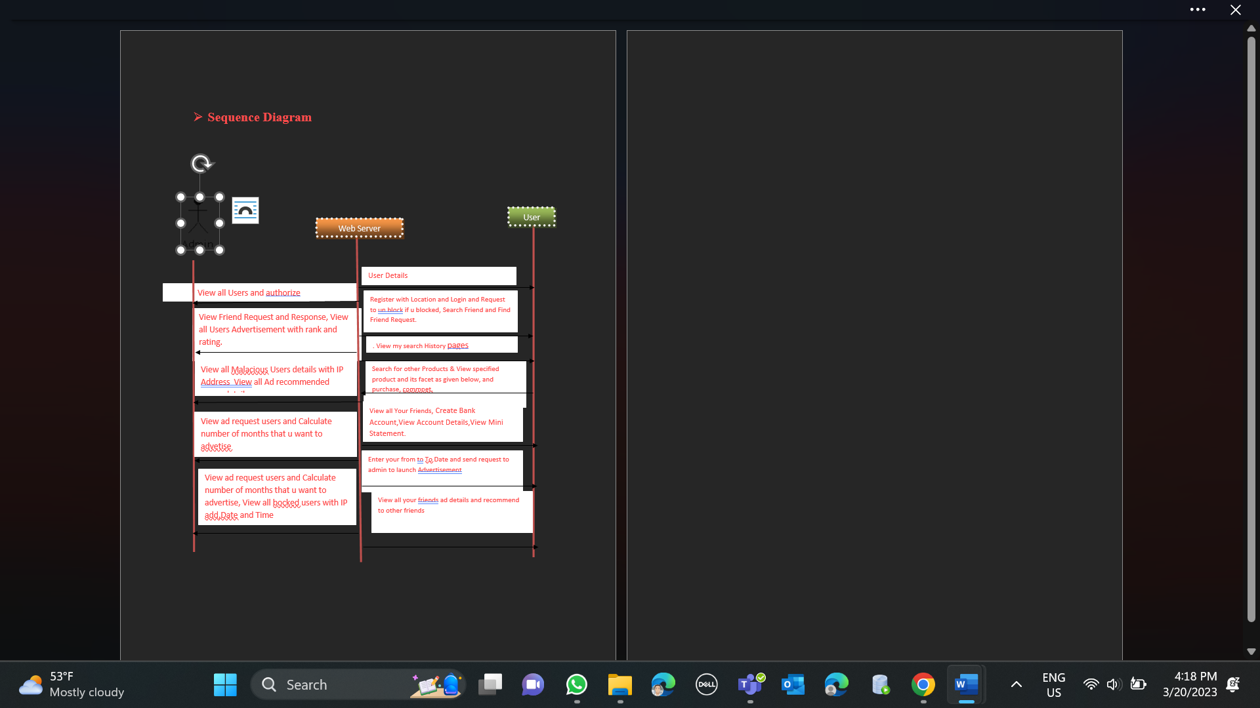

Figure : Sequence Diagram

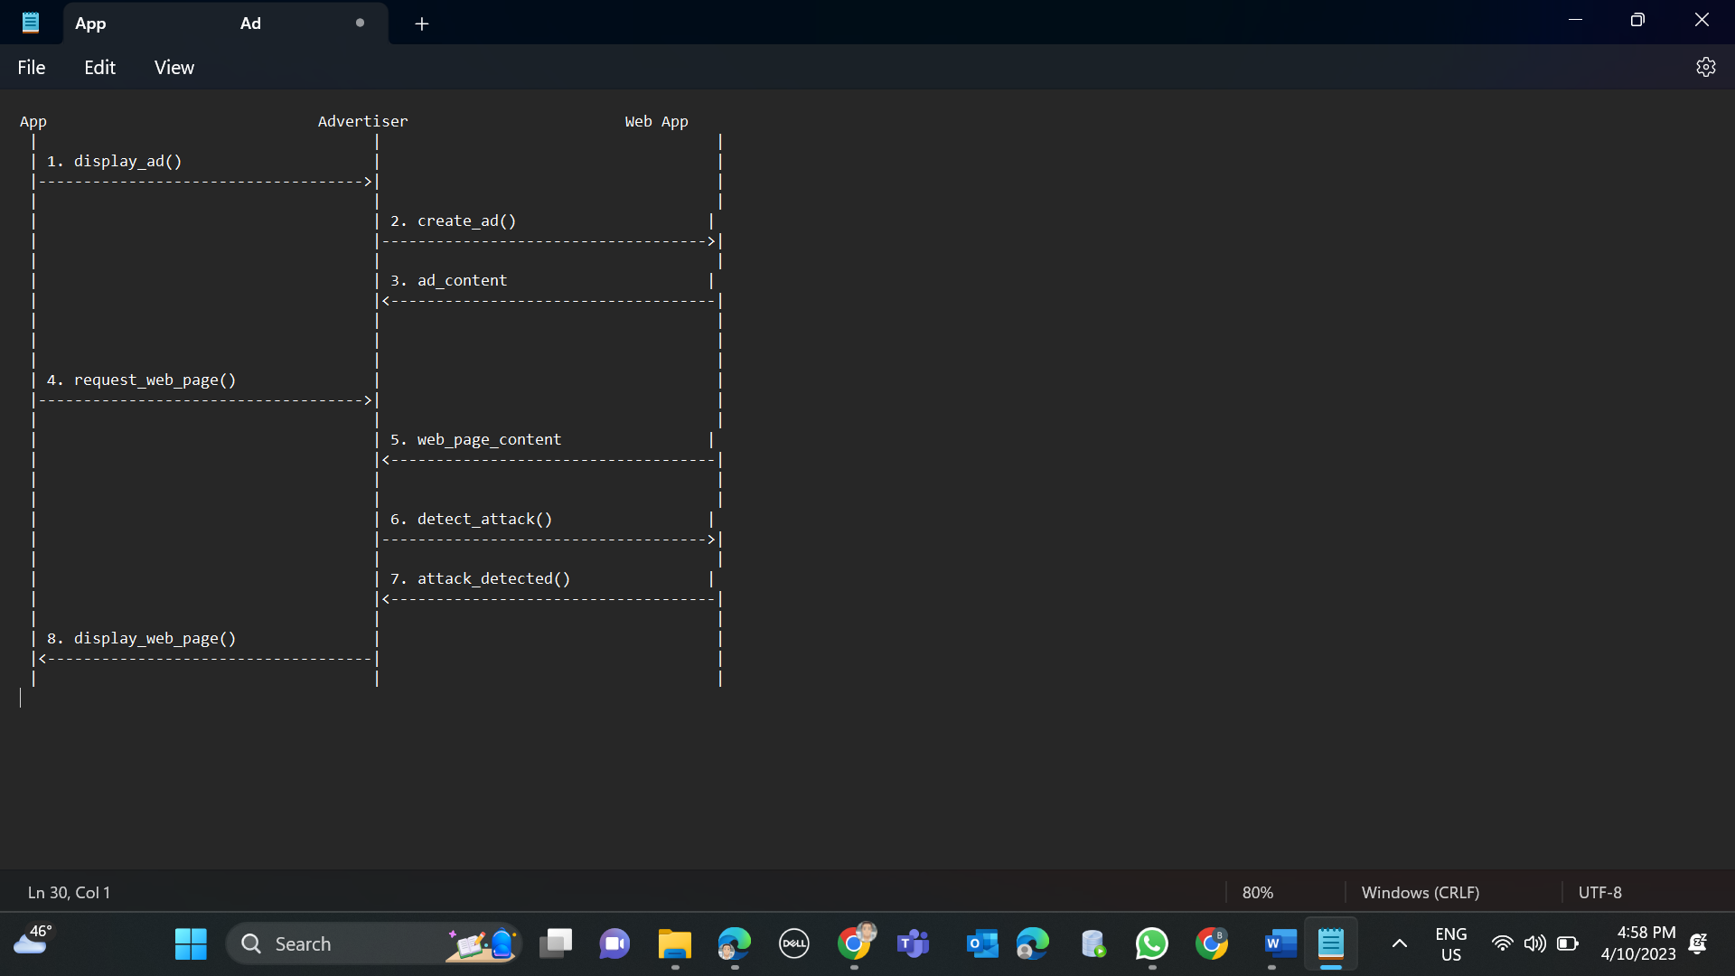

## Use case diagram

Use Case diagram for “**Understanding In-app Ads and Detecting Hidden Attacks through the mobile App -Web Interface.**” with respect to the Phase – 1 Requirements.

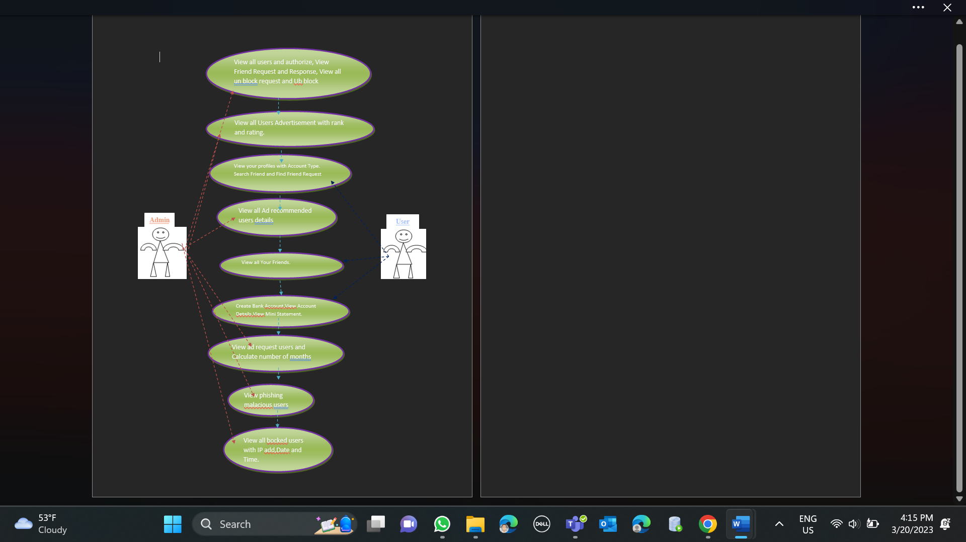

Figure : Use-case Diagram-normal case.

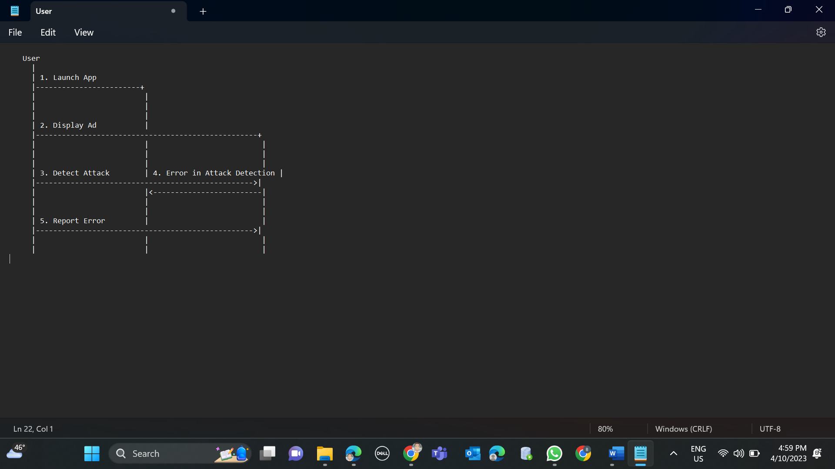

Test Cases

Test Cases:

1. To access the admin page here we need to provide the valid login credentials. If we fail to provide those credentials it will throw error. Based on this condition we tested the application, and the result was Pass.

In the below screen shot admin home page has shown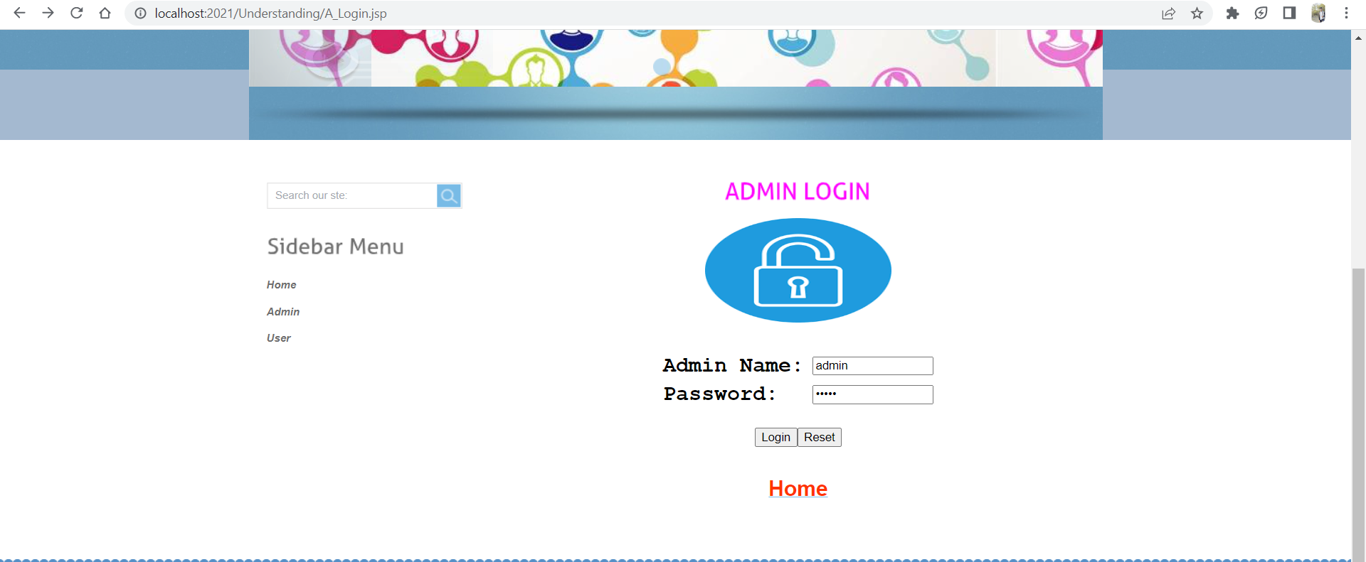

If we gave wrong login credentials, then it will redirect to this page

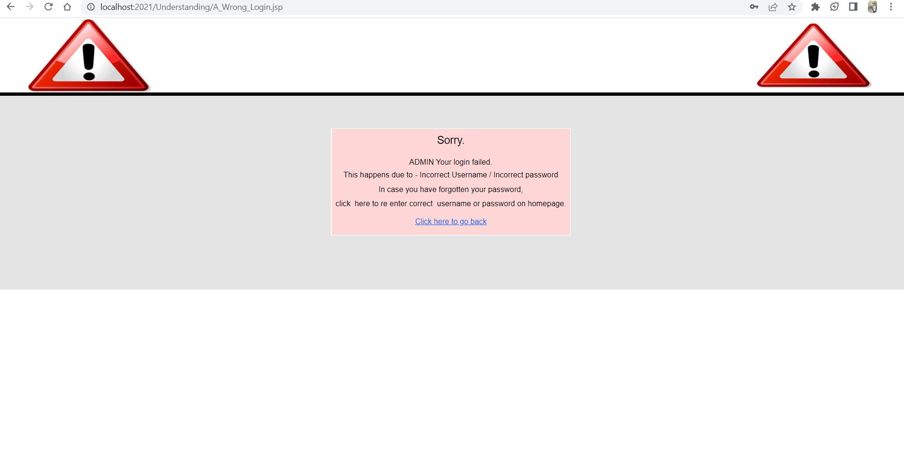

If we gave Correct credentials, it will display the admin welcome page

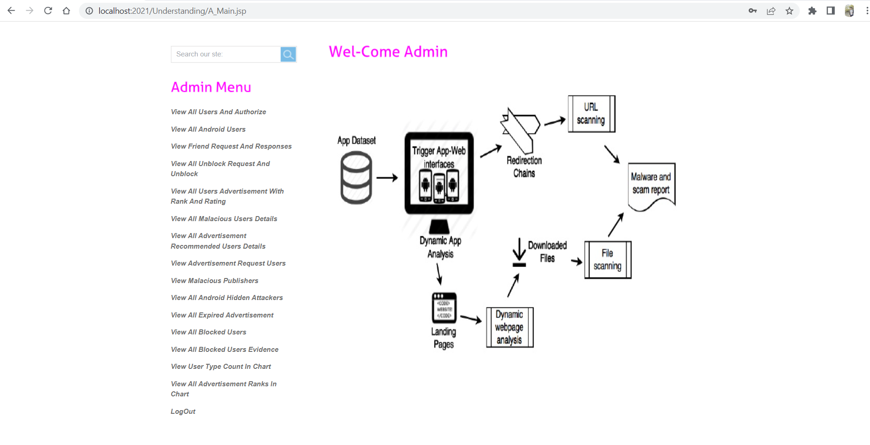

1. Similarly, we tested the user page also. This test case result was Pass.

In the below screenshot We entered wrong credentials.

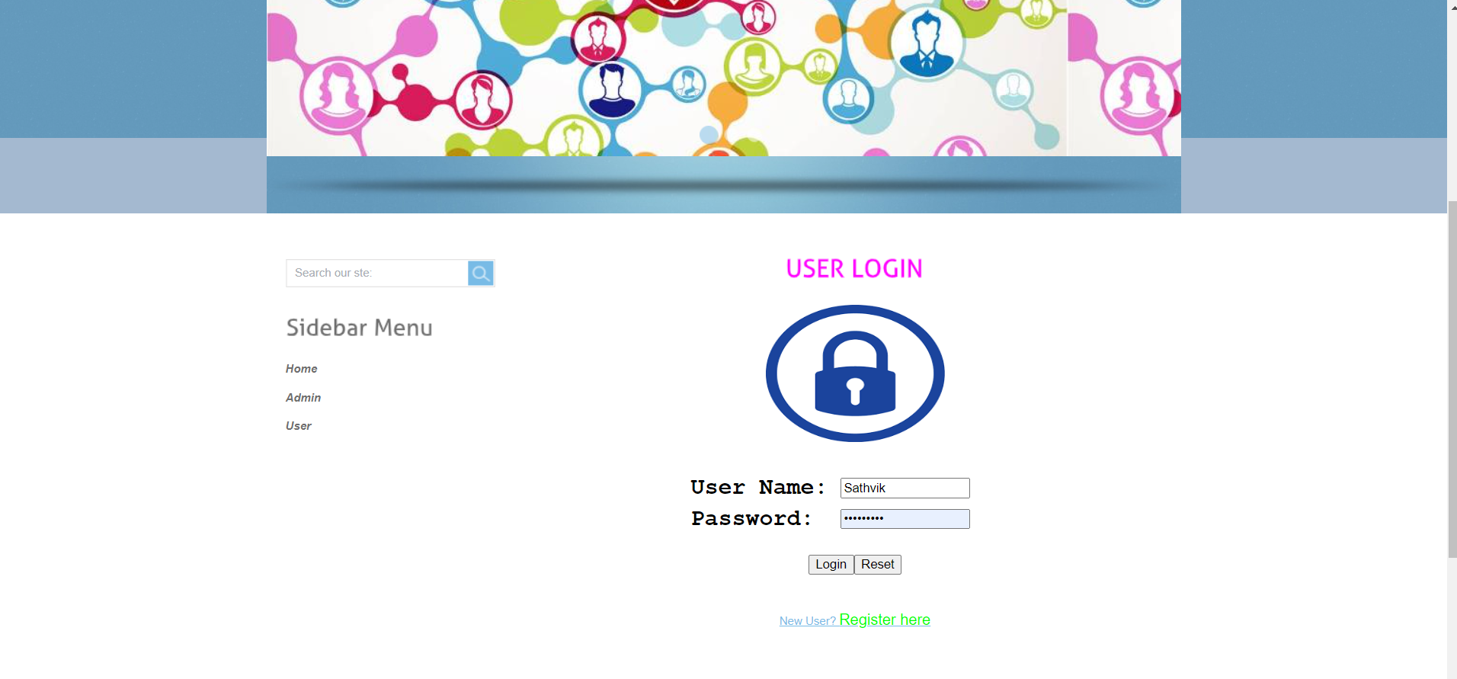

As we entered wrong credentials, the error as shown in the below screenshot

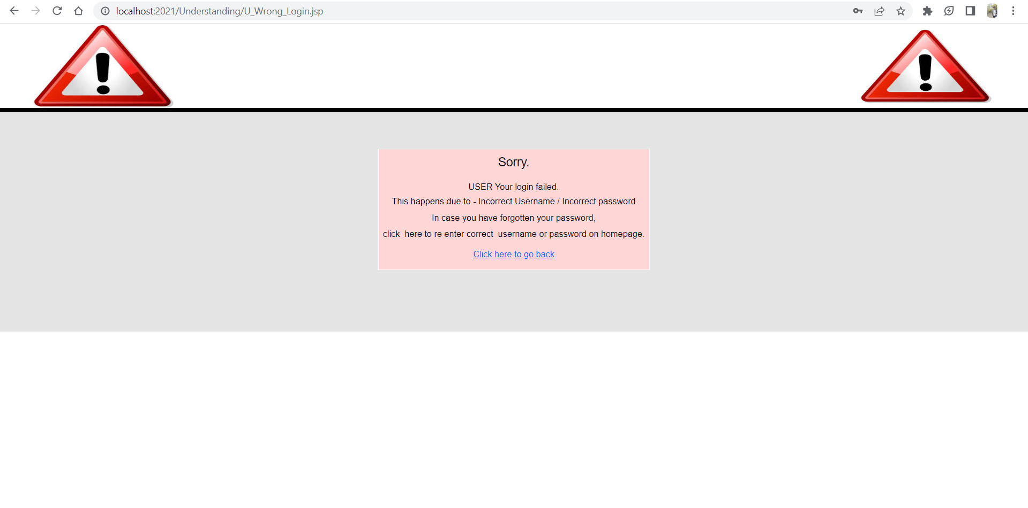

This time I gave correct credentials so, it is navigated to the user welcome page. 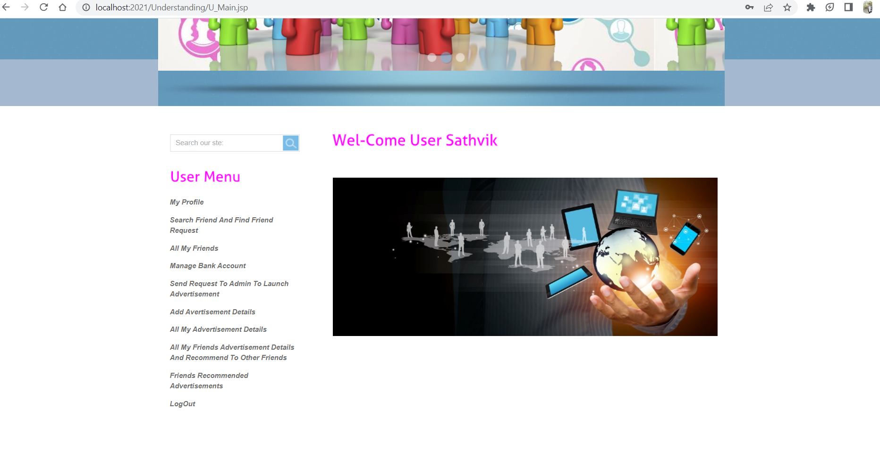

1. In this case we tried to login without giving any credentials, then the pop-up need to show for Please enter the credentials and this testcase result was Pass.

In the below screenshot we displayed popup window.

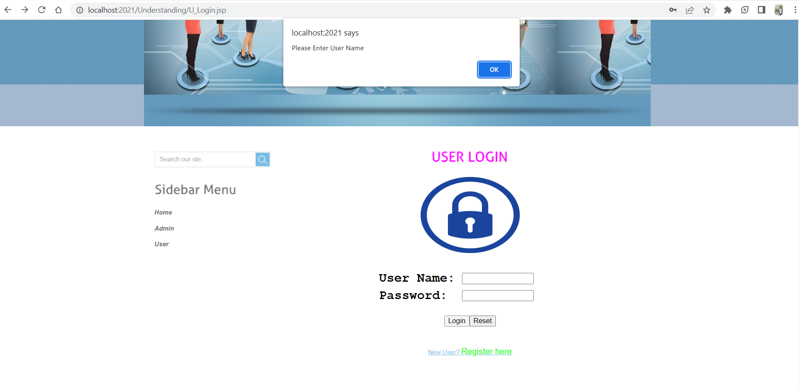

1. If the user is new to this application, he/she need to must register for accessing the webpage. For this case register page also working properly and this test case result was Pass.

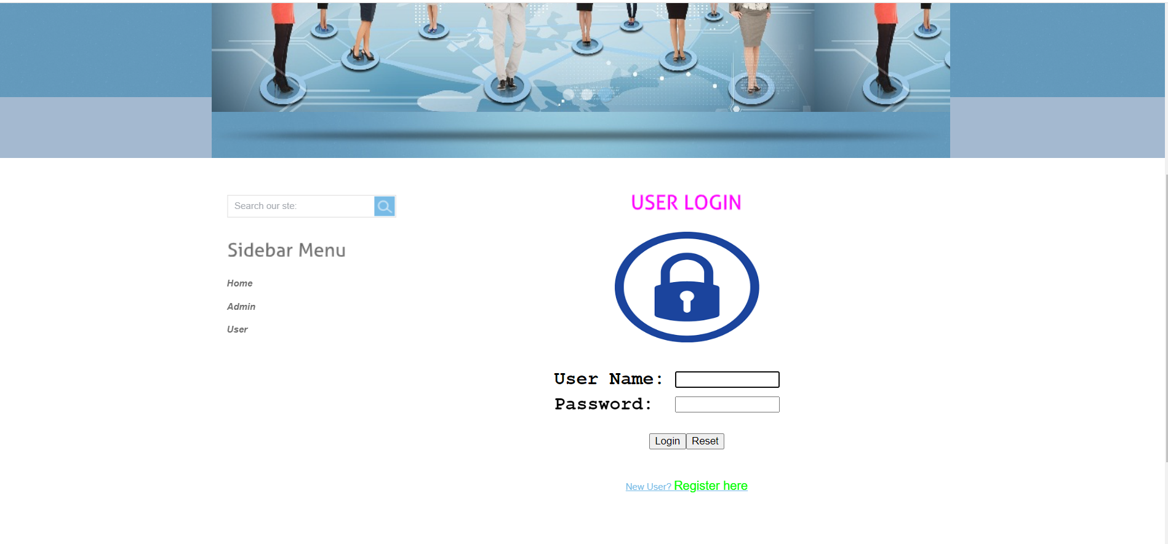

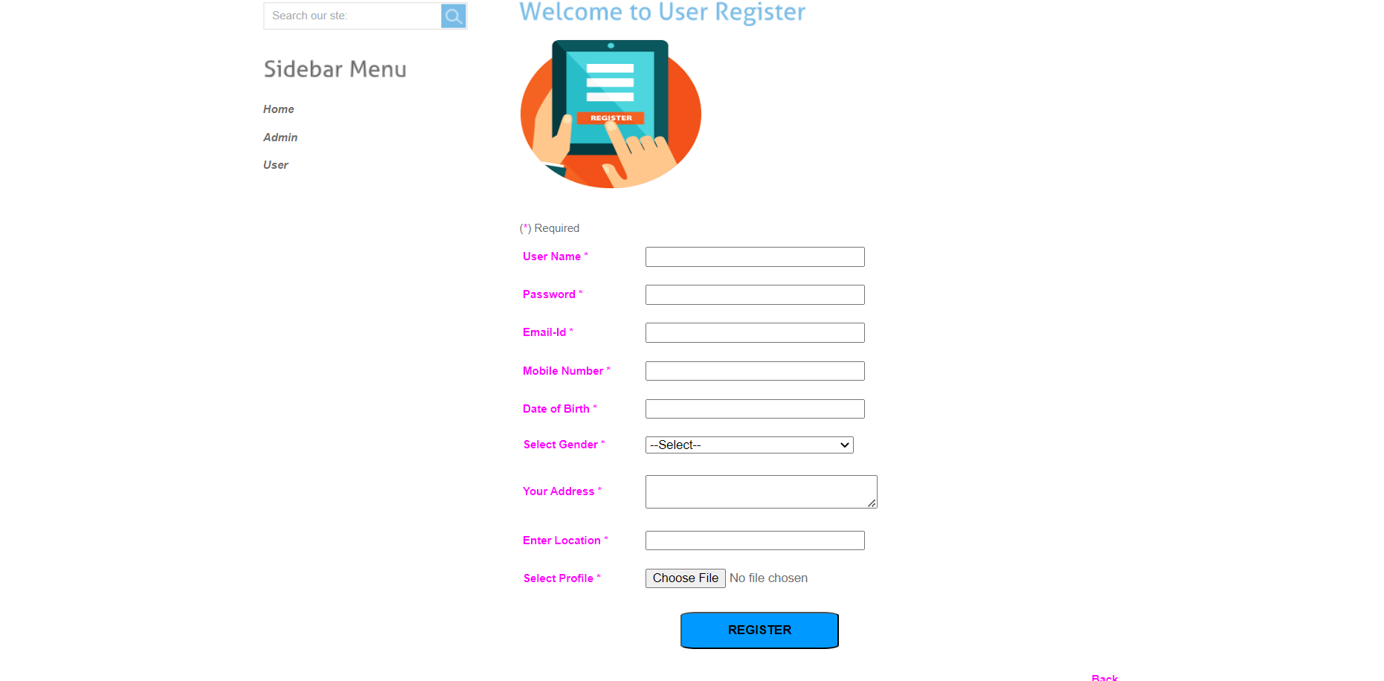

1. In this case we are trying to register without giving any details about the user. Popup windows need to show here for entering the details.

In the below screenshot that is what we shown and result of this testcase was Pass

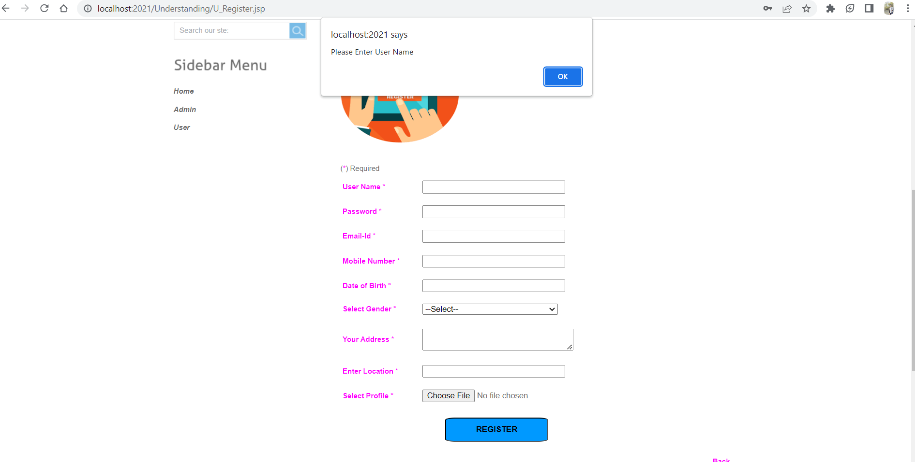

# Program Compilation and Run Instructions

1. **Program Instructions**

To compile and run your program and test cases on your local system, you need to follow the instructions provided below. Ensure that you have installed all the required software and dependencies before proceeding.

For this, the program must be compiled before it can be executed or run.

***Compilation****:* The first step is to compile your program using an appropriate compiler or build tool. This is necessary to generate the executable files that can be run on your system.

***Running the program:*** Once the compilation process is complete, you can run your program by executing the generated executable file.

Here is the detailed explanation of the steps to follow to compile and run the program on your local system using Tomcat server.

1. **Download Tomcat:** To run your program on your local system, you first need to download and install Tomcat server. You can download Tomcat from the official Apache Tomcat website. Choose the version that is compatible with your operating system and download either the ZIP or TAR file.
2. **Extract the files:** After downloading Tomcat, extract the contents of the ZIP or TAR file to a directory of your choice. This will create a new directory containing the Tomcat files. You can extract the files using any extraction tool that you prefer, such as WinRAR or 7-Zip.
3. **Start the server:** To start the Tomcat server, navigate to the bin directory of the Tomcat directory that you have just extracted, and run the startup application named ‘Tomcat8.exe’.

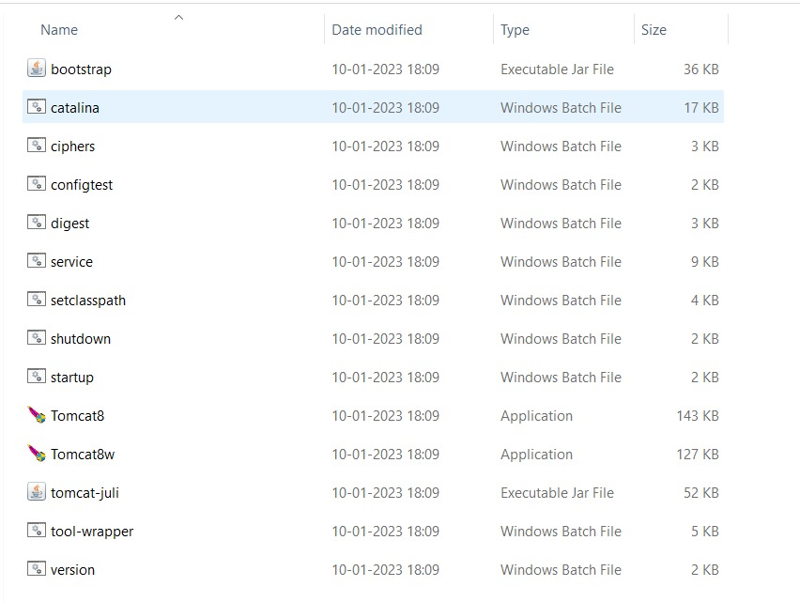

This will start the server as shown in the below screenshot and make it accessible at <http://localhost:2021/>.

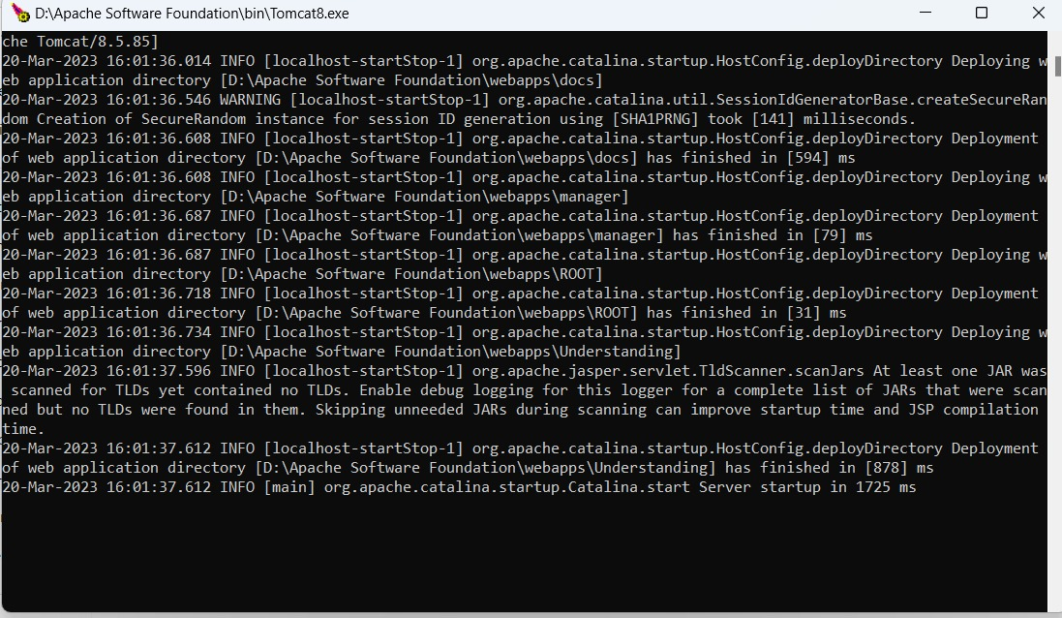

1. **Verify the installation:** For the verification of running the Tomcat server successfully, choose any web browser of your choice, open it and run the address as <http://localhost:2021/> . You can observe the Tomcat home page which is the default page of the application as in below screenshot. This confirms that Tomcat is running correctly on your system.

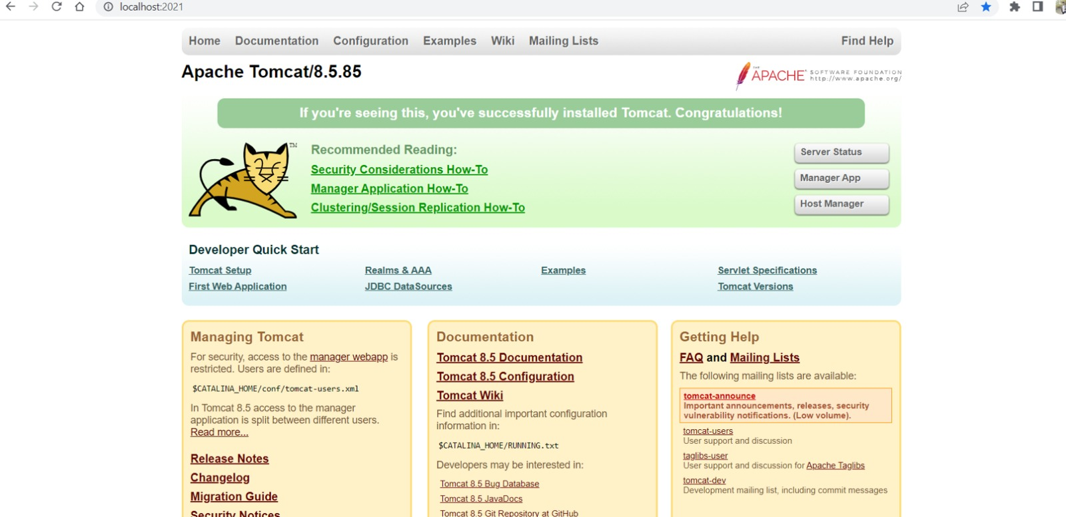

1. **Navigate to the application:** To navigate to the application’s home page, click on the Manager App button, which will take you to the Tomcat manager page where the list of all the available applications is showcased as in below screenshot.

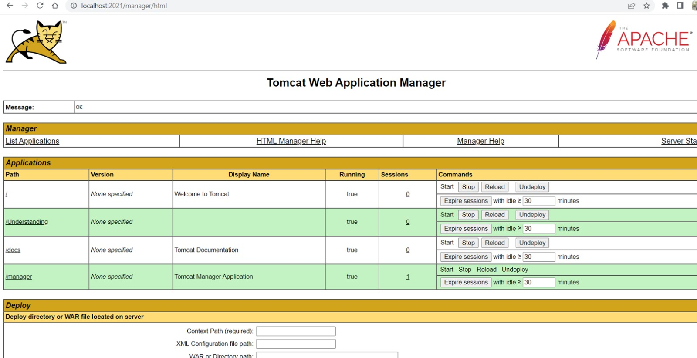

From there, click on the application that you want to run. As our application is ‘/Understanding’, click on that. If your application requires any credentials or login details, you will be prompted to enter them at this stage as shown in the screenshot below. For our application admin credentials are required.

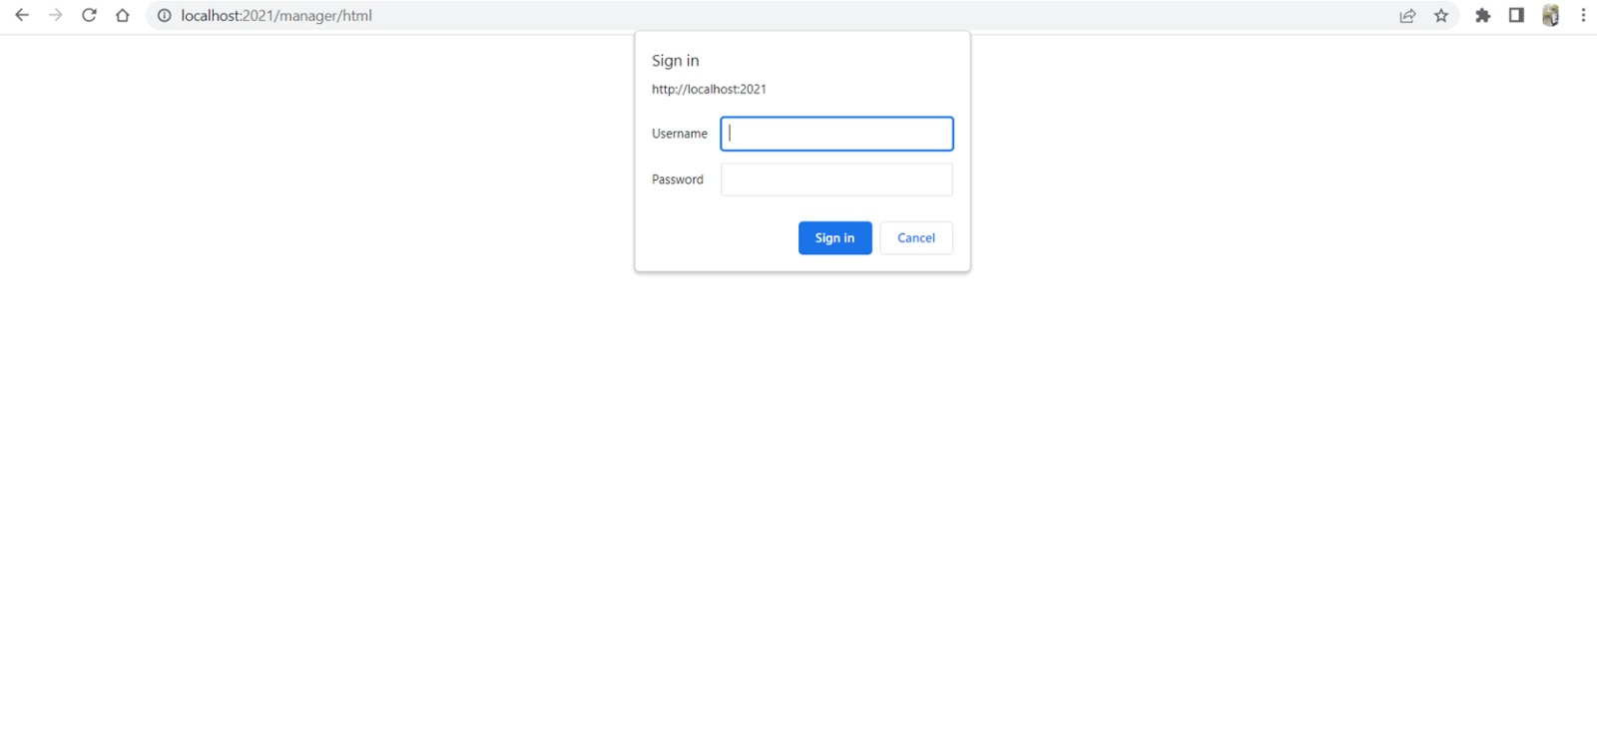

Congratulations, you have successfully installed and configured the Tomcat server and your application on your local system.

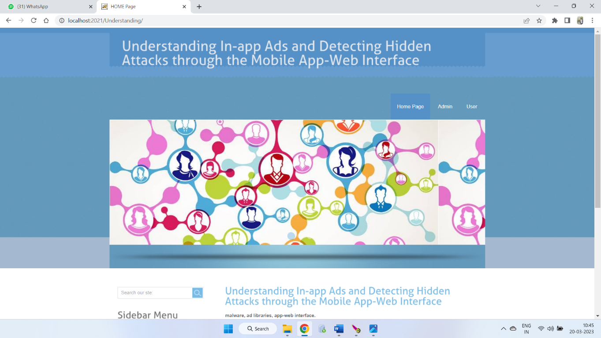

1. **Closing the server:** To stop the Tomcat server, navigate to the bin directory of the Tomcat directory and run the application named ‘Tomcat8w.exe’. This will open a command pallet where you can see that the server has been stopped.



1. **Testing Instructions**

This project is developed as a web application, which means it runs on a web browser. Therefore, to test the application, you need to launch it in a web browser and execute the program directly on the browser. The web application provides a user interface that allows you to interact with the program and test its functions. By executing the program on the browser, itself, you can verify that the output generated by the application is correct and matches the expected output.

To ensure that the application is functioning correctly and meets the required specifications, test the application by following the steps given below:

1. **Setup the application:** Make sure that you have set up the application correctly on your local system by following the installation and configuration instructions provided.
2. **Launch the application:** Launch the application by navigating to the URL http://localhost:2021/ in your web browser. This should take you to the home page of the application.
3. **Test each function:** Test each function of the application by using the user interface provided. Make sure that all the buttons, links, and forms are working as intended. Test each feature of the application thoroughly as per the Test Cases provided above to ensure that it meets the required specifications.
4. **Verify the output:** Verify that the output generated by the application is correct and matches the expected output. Ensure that the application is able to detect and prevent hidden attacks in the in-app ads.
5. **Test edge cases:** Test the application with different inputs and edge cases to ensure that it handles all possible scenarios correctly. Make sure that the application is able to handle unexpected inputs and errors gracefully.
6. **Repeat the testing:** Repeat the testing process multiple times to ensure that the application is consistent and reliable.

In summary, to compile and run your program and test cases on your local system, you need to compile your program, run the executable file, and utilize the user interface of the web application opened in a web browser to run your test cases. By following these steps, you can ensure that your program works correctly and meets the required specifications.

## Testing Instructions

As it is web application, most of the test cases executed as a part of Phase-1 were directly evaluated on the browser. Below are the steps:

The first step in testing is to prepare the application. In this case, the application is a web-based program that runs directly on the browser. Therefore, we will test each function of the program directly on the browser.

# Feedback

**Feedback Received:**

1. ***User Interface Design:*** Enhance the design of login and registration pages to make them more visually appealing and user-friendly.
2. ***Security:*** Address potential security vulnerabilities in the code including additional checks to ensure proper validation and handling of user inputs.
3. ***Block and Unblock Feature:*** Implement a feature that enables users to block and unblock other users in the application.
4. ***External Bank APIs:*** Integrate external bank APIs to allow users to use their existing bank accounts within the application.

**Accepted:** Actions taken based on feedback

* The partner team suggested enhancing the UI design for login and registration pages. Our team agreed and implemented a more visually appealing design to improve the overall user experience. We added a theme to the registration page and improved the button design to make them more prominent. The goal was to make the registration process seamless and user-friendly, leaving a positive first impression of our platform.
* The partner team had suggested implementing a feature to block and unblock users in the application. Our team agreed with the suggestion and implemented it in our application. This feature enables users to temporarily or permanently restrict other users' access to certain features or content in the application. Users can block another user by clicking on the “block user" button on the user's profile. Once a user has been blocked, they will not be able to send messages or interact with the blocking user in any way. The blocking user can also choose to unblock the user at any time, restoring their access to the application's features and content. This feature has been successfully implemented and tested, and we are confident that it will provide a safer and more secure experience for our users.
* Based on the feedback received, the team updated the code to include additional checks and validations for user inputs. This involved implementing more robust input validation functions that would catch potential vulnerabilities and prevent them from being exploited.

**Rejected:**

* *Security of the project*: acknowledged that the security of the project is a concern but may not be able to implement advanced security features due to time constraints and complexity.
* *Use of external bank APIs:* acknowledged that this feature would improve user experience but may require significant technical resources and ongoing coordination with external banks.

# Accomplishments

A Complete reflection of work for this phase:

1. In this Increment we worked on all the three modules of the project and the database.

2. In the Admin Module we worked on the changes should be made to the other modules according to the request raised by the other users like functionalities triggering to permit the request of posting adds and blocking users according to the ads posted.

3.In the Mobile User module there should be the functionalities affecting the database according to the requests made by the admin side.

4.Updating the database according to the modules requirement with some extra records and also some new attributes(Columns) for effective working of application.

# Member contribution table

|  |  |  |  |
| --- | --- | --- | --- |
| **Member Name** | **Contribution Description** | **Overall Contribution (%)** | **Note (If Applicable)** |
| **Sushma Bobbishetty** | Functional and Non-Functional requirement specification and Full Stack Development, worked on all components. | 15 |  |
| **Sathvik Cheekati** | Program Compilation and Run Instructions. Front-end development of customer, employee, and manager modules. | 16 |  |
| **Navyasri Arekatla** | Test Cases and Back-end development of customer, employee, and manager modules. | 12 |  |
| **Naveen Bolgom** | Feedback and accomplishments. Back-end development of customer, employee, and manager modules. | 12 |  |
| **Lokesh Bachu** | Code-inspection document. Front-end development of customer, employee, and manager modules. | 15 |  |
| **Vamshi Teja Goud Puli** | User Manual and Application Layer Development. UML Designs and Initial Integrated Testing. | 13 |  |
| **Shiva Teja Reddy Yammanuru** | Code-inspection document and GitHub update and Application and UI Development. | 15 |  |

# VIII Reflection

In this phase of the project, we have accomplished the following:

1. Further developed the application layer using Java Servlet pages to enhance the functionality and performance of the web interface.
2. Updated the front-end web pages for all the modules to include additional functionalities and improve the user experience. We continued to use Ajax, jQuery, and Servlet pages for the development of the back-end.
3. Made necessary updates to the database to ensure that it maintains a good flow in all the domains of the project.
4. Performed further development of the back-end for the updated Admin, User, and Android modules, ensuring that all functionalities are properly integrated with the system's database and architecture.
5. Implemented the features that are accepted from the peer team’s suggestion received during code inspection workshop.
6. Conducted extensive testing to ensure that the system is functioning correctly and is free from errors. We have deployed the application using Apache Tomcat server and performed thorough testing to ensure that all functionalities are working as intended.

Overall, the team accomplished significant milestones in the development of the project, including the creation of a functional database, development of application and front-end layers, and integration of various components. We were able to successfully update further features and also the suggestions provided by the partner team, which resulted in the improvement of the application's security, user interface, and overall user experience. Our team continued to work collaboratively and effectively, with regular training sessions to ensure everyone is on the same page. However, we could improve on communication and collaboration between team members and also we could have improved the testing process by conducting more thorough and comprehensive tests before deploying the application.